Director General
Telecommunications Policy Branch
Industry Canada
300 Slater Street
Ottawa, Ontario
K1A 0C8

10 July 2009

Dear Sir/Madam,

The Canadian Low Frequency Experimenters Group and the Marconi Radio Club of Newfoundland are grateful for the opportunity to comment jointly on the proposal to add an allocation to the Amateur Radio Service in Canada in the 135.7-137.8 kHz band as outlined in the Canada Gazette, Part 1 dated 1 May 2009, reference number DGTP-003-09.

The Canadian Low Frequency Experimenters Group comprises knowledgeable amateur radio operators who have considerable experience in designing, constructing and operating radio transmitting and receiving apparatus for use on the Low and Medium Frequencies. In March of 2007, members of this group contributed to a report on Canadian experimentation on 2200 metres, attached herewith. Mr Tilley has also prepared a report on 2200 metre experimentation. In February of 2007, a document entitled "A Canadian 600m Experimental Program Proposal" was prepared by Jay Allen (VY1JA) Joe Craig (VO1NA) John Gibbs (VE7BDQ) Steve McDonald (VE7SL) Martin MacGregor (VE7MM) Mitchell Powell (VE3OT) and Scott Tilley (VE7TIL). A copy was sent to RAC. Members of the Canadian Low Frequency Experimenters group continue to discuss matters of interest.

Marconi Radio Club of Newfoundland were incorporated in 2001, the centenary of Marconi's first transatlantic wireless experiment, with the objective to promote science and technology. In meeting this mandate, it collaborated with experimenters across the country to generate new knowledge in support of an allocation on the 2200m band. These experiments are outlined on the MRCN web page along with an extensive bibliography and reports that were submitted to Industry Canada and Radio Amateurs of Canada. MRCN has participated in several notable experiments on 600m in collaboration with European and American amateur radio experimenters who are authorised by their respective administrations to transmit near 500 kHz.

We are pleased to endorse the proposal for the allocation of a new LF band for the Canadian Amateur Radio Service as outlined in DGTP-003-09 with our full support. We also wish our express our support the adoption of a similar 2200 metre band plan as in place in Region 1 and that safety considerations and operator competencies specific to the transmission on the 2200 metre band be considered based on the established experience of our group members.

Yours very truly,

J. Craig, S. McDonald, S. Tilley

Final Report of the Canadian 2200 metre Amateur Radio Experiments

Contributors: J. Allen VY1JA J. Craig VO1NA and S. McDonald VE7SL
Please note that S. Tilley VE7TIL had prepared a separate report that is considered part of this submission.

This document may not be cited nor otherwise circulated without the prior permission and acknowledgment of the author(s). References cited herein shall be taken as the more authoritative account. Some of this material is copyrighted. Copyright remains with the respective authors.

Introduction:

Since preparations for WARC79, radio amateurs have sought authorization to experiment on long waves, having been relegated to MF and above since the early part of the 20th century. Success was finally realised almost 3 decades later when, following the lead set earlier by the Canadian delegation, a world-wide amateur allocation of 2.1 kHz between 135.7 and 137.8 kHz was approved at WRC07.

The allocation of this band is a domestic matter and up to the individual administrations. The purpose of this report is to provide documentation in support of a Canadian allocation for Radio Amateurs of Canada in their deliberations with Industry Canada, the body responsible for allocating amateur bands in this country.

The three reports deal with different locations and geography, spanning coast to coast to coast: British Colombia, Yukon and Newfoundland & Labrador and outline largely independent work towards developing practical amateur LF communication systems using a variety of modes and equipment and communication techniques. These systems were essentially built from scratch and are typical of traditional amateur experimentation, persistence and innovation.

Despite the close contact maintained with the regional IC office and the use transmitter powers of up to 1.2 kW, there were no reports at all of any interference to other services in the bands. In addition, some of the portions of the reports deal directly with coupling of LF to the power grids and methods of mitigating this effect. Again, there were no reports of interference to any control and monitoring apparatus associated with the power grids.

Our results show that practical LF systems can be developed and safely operated by competent amateurs, that LF is a excellent venue for the development of new techniques for transmitting and receiving and that the allocation of Canadian 2200m band will further the cause of amateur radio in Canada. This will ensure a continuance of the international camaraderie and interest in the development of the state of the art within the amateur service in this country and abroad.

Report of Experimental Low Frequency Operation
By
J. Parke Allen, VY1JA

Whitehorse, YT,

Date: Wednesday, May 2, 2007

Subject:
2200 meter band characteristics:
- (Primary) Auroral effects on propagation in the near-arctic,
- (Secondary) Propagation characteristics over mountainous terrain,
- (Secondary) Practical antenna systems for rural acreage,
- (Primary) Interference potential with Power Line Carrier systems on 137 kHz.,

Purpose:
The initial purpose was to conduct experiments with transmission and reception in the frequency range of 135.7 to 137.8 kHz centred on the items in the first three subject areas noted above. During the course of the experimentation, it became apparent that station VY1JA is ideally situated for its operator to examine interference potentials to Power Line Carrier (PLC) systems which are used by the power utility companies in Canada and other parts of the world for power system supervisory control and data acquisition (SCADA) systems. Representatives of power companies have expressed concern that amateur operation on PLC frequencies might have the potential to jeopardize power system supervision and/or control stability.

The antenna at VY1JA is located near the 138,000 volt transmission line which runs north and south, along the east end of the acreage on which the station is situated. The voltage ends of the low frequency antenna were as close as legally allowed to the power line, which is within approximately 50 feet. The height of the antenna wires was set to match the approximate height of the power line as well. This is a worst case scenario, providing for maximum coupling of an amateur radio signal into the transmission line. Also, as much as possible, VY1JA was set in beacon mode on a 24/7 basis so that the greatest time exposure for interference existed as well.

When experiments were directed toward the first three purposes, the potential for interference with the power system was monitored continuously and would have been controlled if it had become necessary.

The SCADA technician at Yukon Energy Corporation (YEC), Robert Burrell, was kept informed of the experiments, exact frequency of operation and the modes involved. During all 137 kHz. experiments, no signal was detected in the PLC system from these LF operations, despite the fact that the power level was kept as close to the maximum allowable limit and was seldom below -3dB of that calculated limit during this period and then only for brief periods of operation.

Progress, Plans and Notes:
In the first year of experiments, the antenna, a top loaded vertical with an effective height of the capacitance hat of 70 feet was installed using a 110 foot tower and two, 400 foot long capacitance wires. The antenna was base loaded and proved effective in reception because of the uncommonly quiet receiving environment found in the Yukon. Reception was made and reports were given via both public and private means to those running similar experiments, especially those centered in southern BC. During the reception experiments, experience has been gained in the use of the DSP software for receiving signals far below the noise floor.

On the transmitting side, base loading and matching were completed and Robert Burrell at YEC was notified before the initial transmissions were made using a test power level approximately –10dB below the level allowed by the experiment permit. After establishing non-interference at this level, the power company was notified and the power level was moved up to the operational range and kept within 3 dB of the license limit. Several frequencies were used within the allowed spectrum and while most of the experiments were very narrow bandwidth due to their slow speed, wider bandwidth signals from 15 WPM Morse code contacts with southern BC produced no signs of interference as well.

Careful observance of possible effects on the PLC system meant that the full range of the experiment and propagation observation was done without detection or interference with the power line carrier system in any way.

Propagation Experiments:
Whitehorse, Yukon is exposed to some levels of auroral activity approximately 255 days of the year. The area is more centred under the auroral halo than most of western or southern Alaska, and therefore more suited to this type of experimentation.

This experiment contributes to the growing base of knowledge with results of one-way and two-way communications during varying levels of auroral activity which occurs in the mountainous terrain north of Whitehorse, Yukon. The propagation experiment results, contributed by amateur radio operators, demonstrates the advantages of having a Canadian amateur segment in low-frequency portion of the radio spectrum.

For several years before being given initial permission to begin LF experiments, I had been conducting personal and unpublished HF and MF experiments concerned with propagation during times of varying Auroral activity, observing the propensity toward an observable increase in one-way propagation and loss of east-west propagation in the near-arctic on HF, increasing in effect as frequencies are lowered into the MF range. This had included total loss reception at southern stations of the near-arctic transmitted signal, while the signal received in the near-arctic from the southern transmitters were reasonably strong. One of the purposes of this experiment was to continue experimentation into the LF range to see if the disparity between received signal levels continued to increase with decreasing frequency, in the LF range.

During the propagation tests Scott Tilley, at VE7TIL, and Steve McDonald, at VE7SL, were primary participants, either monitoring or transmitting while their signals were monitored in Yukon. Scott keeps a signal monitoring station which generates a computer screen display of the received signals and sends this information to his webpage. This, “Grabber” was particularly beneficial in comparing the received signals over time and at a distance approaching 1000 miles.

Here are some of the principal observations of propagation at Whitehorse, Yukon:

- Propagation during periods of higher Auroral activity:

- North-south path
Higher Auroral activity levels appear to cause or at least coincide with one-way propagation on north-south paths. This was true at MF and HF and appears to be true on LF as well. The effect is stronger here (LF) than on MF. It was displayed primarily with the stronger signal being the received signal in Yukon and the weaker signal being received in southern locations. It is notable that on MF and HF a direction of best reception reversal occurs very seldom and on LF the reversal is increased significantly, but still occurs far less than one way where Yukon transmitted signals are the weaker.

- East-west path
Higher auroral activity levels appear to cause or at least coincide with loss of propagation on east-west paths. This was true at MF and HF, and appears to be accentuated on LF. The east-west paths which are near or under the auroral halo are the most greatly impacted. This meant that signals over the east-west path were often not received at all when auroral activity was greater.

Technical Operation Data:

- Operational
- Transmissions were limited to fall between the frequencies of 135.7 and 137.8 kHz, in the 2200 metre band.
- Emissions outside of this frequency range were suppressed by a minimum of 30db below the fundamental signal.
- Bandwidth of the transmitted signal was limited to 100Hz or less.
- Radiated power did not exceed 1 watt ERP, and was kept within -3dB to 0dB of 1 W for the duration of the experiments except for brief testing periods.
- The license period was from December 2004 to May, 2007
- The transmitter was operated with care not to interfere with authorized users. Authorization for experimental transmissions was on a secondary user basis. There were no requests from primary users to cease transmission or to change frequency during the period of these experiments.
- Care was taken to watch for possible interference with the Power Line Carrier system of Yukon Energy Corporation. No LF amateur signal interference to the PLC system was generated by these experiments.
- Transmissions were identified at the beginning and at least once each half hour with the callsign VY1JA. Often text was sent on Dual Frequency Continuous Wave (DFCW) or on QRSS CW, very slow CW, and with dit lengths up to 120 seconds in length. At these speeds, the callsign was sent at ~12 wpm and the slow text followed.
- One-way (beacon) communications were run on a 24/7 basis and reports were solicited and received from British Columbia, the United States, and Europe. These were used specifically comparing the north-south and east-west propagation auroral paths.
- Two-way communications were attempted with other licensed experimental stations and resulted in establishing that reliable slow speed communications can take place with stations even on a small city lot, and that reliable communications on Morse code at speeds of approximately 15 wpm are possible on most evenings, during the hours of darkness, between two stations with good transmitting sites.

- Station

- Antenna

The antenna was a 30 metre (100 ft) top-loaded "T" with the top hat consisting of a pair of loading wires averaging approximately 120 metres (400 ft) in length. A large variable air-core loading coil “Variometer” was used to tune the antenna against a surface ground-contact radial system. A 1:1 air wound LF balun was used to isolate the transmitter from the antenna system.

The antenna match was checked by using a dual-trace oscilloscope with one input monitoring the current and the other input monitoring voltage at the same spot on the RF feedline to the antenna. It was noted that with the LF antenna being this size, there was very little change in antenna match during changing weather. However, during strong winds, the voltage and current traces would visibly but slightly move away from each other in time with the wind gusts. This is a very interesting thing to see demonstrated.

- Transmitter

The exciter was a Kenwood TS45O which had its transmit frequency opened up so that it generated RF on 13.7 MHz. This was fed through a divide by 50 frequency divider, to feed the amplifier with 274 kHz.

When using DFCW, the transmitter was operated on Upper Side Band mode, and fed 1000 and 1015 Hz AF into the microphone from computer software. This produced a 0.15 Hz frequency shift for the DFCW.

Two different amplifiers were used. These were courtesy of Scott (VE7TIL) and Steve (VE7SL).

Scott’s prototype amplifier used a pair of FETs in class-C push-pull operation, and Steve’s transmitter used a single FET amplifier operated in near class E operation. Both of these amplifiers were constructed by their owners and demonstrate that building amateur equipment for LF is not beyond the skills of the average amateur operator.

Public Notification:
Transmitting schedules and frequencies were published via the Internet "LF" RSGB reflector (North American/European) and via the "LOWFER" reflector (North America).
Articles of interest were sent to popular amateur magazines such as TCA and QST.

Final Report of the RAC/MRCN LF experiment

J. Craig VO1NA
Marconi Radio Club of Newfoundland

1) Synopsis:

The start of amateur LF experimentation in Newfoundland took place when experiments were conducted as early as 1976 with triode oscillators and tank circuits. Authorisation from the Department of Communications to conduct on the air experiments was sought and was in place by 1992 when the first amateur LF transmissions were made in the province. The signals were heard over a distance of about 10 km by VO1FB and VO1KS. The transmitter comprised a 5 stage CW unit with 5 watts output. In 2003, with the endorsement of VE3IQ and VE3PU of RAC and authorisation from IC, the Marconi Radio Club of Newfoundland (MRCN) commenced LF experimentation on 135.7-137.8 kHz and commissioned a low power transmitter based on a class E design with 15 watts of output power and an oven controlled crystal oscillator to produce a carrier of 135.83 kHz with the aid of a frequency dividing circuit. Several cross-band contacts were had with members of MRCN and others to secure signal reports and to experiment with different antenna configurations for transmission and reception. With the aid of advanced digital signal processing, signals were received over 1000 miles away in Boston by W1TAG.

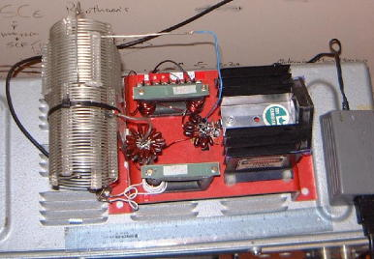
Fig. 1. Photo of 125 watt LF Transmitter

Owing to QRM near 135.83 kHz in Europe, transatlantic reception tests were conducted using a frequency of 137.777 kHz. This frequency was selected in consultation with the amateurs using the 2200m band. A new 100 watt transmitter, Fig. 1, was developed and put into service.
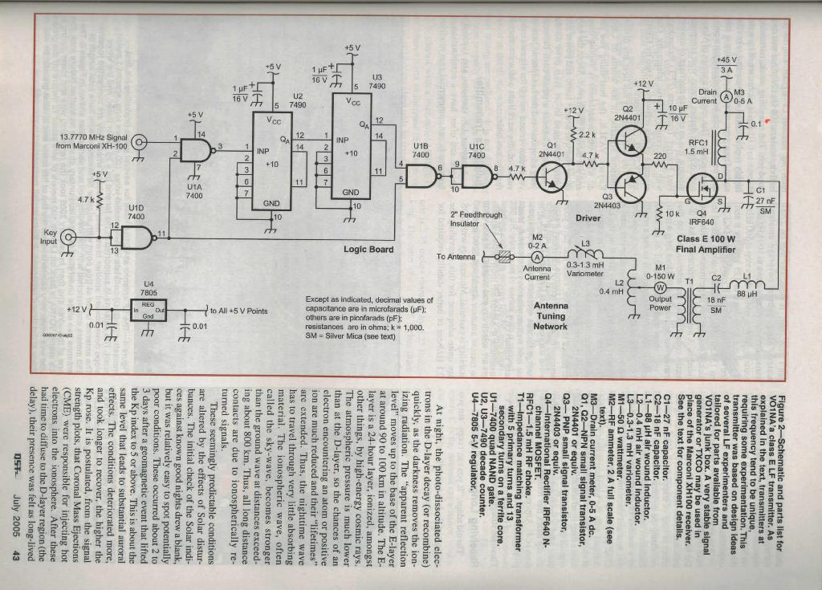
Fig. 2. (Reprinted with permission from July 2005 QST; copyright ARRL.)

It will be seen from the schematic, Fig. 2, that this is a class E design. This was coupled to a wire aerial about 150m long with a maximum height of 25 m using matching and tuning coils including a variometer. The initial reception of the slow speed CW signals in England by G3NYK was followed by several 2-way transatlantic QSOs with M0BMU and others as outlined in the references. Although reception experiments were also conducted in advance transmitting experiments, reception methods were enhanced by the 2-way communication initiatives. High variability in propagation was generally observed with poor propagation following for several days after solar storms. During very favourable conditions, audible signals were heard in France, Germany and Ireland. The best distance over which signals from our station could be copied was 6600km by RN6BN but this was using computer assistance and the signals were very weak.

To explore the utility of LF in local communications, a supplemental request for authorisation was made to operate a second station. VO1MRC was commissioned and operated by VO1HP. The first Canadian LF contact to be completed without computer assistance was between VO1MRC and VO1NA. This showed that a practical LF communications system could be established in a typical suburban residential lot. Further work by VE7SL and VY1JA increased the distance of the Canadian record for conventional CW to over 1000 km. Reliable transatlantic reception of the Newfoundland station was had using ARGO and other FFT based reception techniques using increasingly higher transmission rates up to 6 WPM.

The destruction of the 25m mast during a severe wind and sleet storm in 2005 resulted in an opportunity to test more modest aerial systems. It was found that a wire about 100m long and only 1.5 metres high could be deployed to produce readable signals in Europe. Experimentation continued using a 100m wire raised to a mean height of 10 metres and although reliable transatlantic reception was restored, the reduction in signal strength was estimated to be roughly 10 dB. This was on the basis of several relative field strength measurements taken at a remote station 3 km from the transmitter and measurements of the received signal strength taken in Europe.

To overcome the reduction in signal strength, a commercial amplifier was shipped from the UK using a generous honorarium from the ARRL. The exciter, a modified Marconi XH-100 receiver was refitted to make it compatible with the amplifier. With assistance from MRCN members, a massive power supply was constructed and the 1.2 kW Decca amplifier was commissioned to continue the experiment. Some insights into the potential dangers of high power LF experimentation were noted. During carefully supervised high power testing, the large variometer used to tune the aerial burst into flames during an extended test transmission. Very high voltage gradients can produce potentially hazardous situations. The variometer was replaced by a pair of spider wound Litz helix coils which proved to be quite safe at high power levels for periods in excess of 10 minutes of continuous carrier. The power level was slowly increased by switching in all the PA modules of the Decca amp while adjusting the antenna tuning. A maximum aerial current of just over 5 amperes was realised. Audible signals were reported in Nova Scotia by VE1ZZ and in Germany by H. Wolff. The transmitter continued to operate on 137.7770 kHz, the frequency being referenced against LORAN C sidebands.
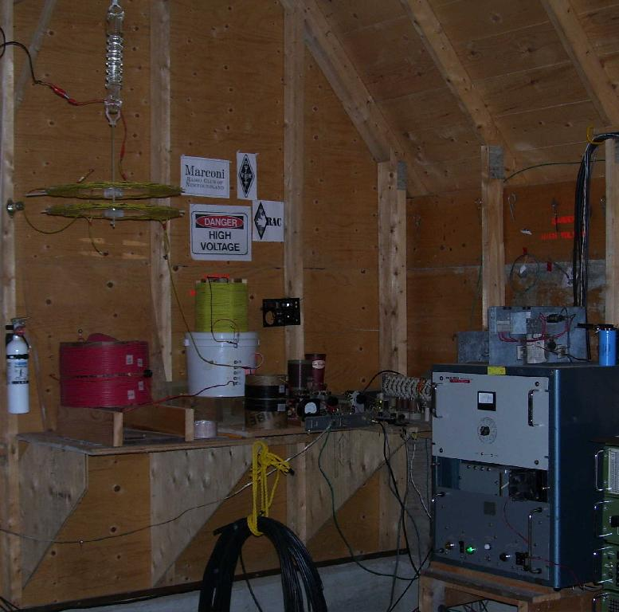
Fig 3 Decca amp and power supply, right. Litz helix coils and tuning apparatus left and centre. Note the fire extinguisher.
Transpacific tests were conducted with ZM2E in an effort to link the antipodes by amateur LF. Although this did not result in a globe spanning transmission or reception at this end, there were significant developments in computer interfacing, software development and transmitter control in producing the FSK transmissions. An interesting display of blue fireworks and symphony of buzzing, pops and bangs were heard one night when high winds blew the aerial wire against the supporting tower. This was easily repaired and the Decca amp was completely unharmed, having a protection feature. The estimated peak aerial voltage was in excess of 12 kV during this high power operation. Finally, fully audible CW signals from our station were again recorded in Europe, and the FSK signals were clearly copied in Russia over 6600km away. The station was decommissioned at the conclusion of the experiment on 30 June 2007.

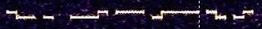

“DE VO1NA” in DFCW (FSK) with a 0.1 Hz shift.

Final 2200m transmission from Newfoundland using slow speed CW. Thanks to H. Wolff in Germany. “TNX TO ALL ON LF GL DE VO1MRC/VO1NA AR SK” Note the wide range of signal strength over the span of 3 hours.

Results of Antenna experiments:

The antenna design experiments involved the development of tuning circuitry and instrumentation. Tuning and matching followed standard LF practice whereby the aerial reactance was estimated and tuned using an inductance. Matching was less of an issue as the resistive components were generally of the order of 50 ohms and only marginal increases in the aerial current could be obtained by matching the resistive component. It was found that with care the antenna could be tuned using the aerial current, although this created certain problems with class E transmitter stages. Under these circumstances, an SWR bridge was necessary. A commercial amplifier could be tuned using the aerial current and the instrumentation on the amplifier.

Long wire antennas were tried. These consisted of wires 100m long and at heights ranging from 10 to 25 metres. It was found that reliable transatlantic reception at 100 watts output was possible for a 100m wire at 25 metres and for 1000 watts for a wire at 10 metres. Under favourable conditions, transatlantic reception at much lower power levels was possible.

Because any practical LF antenna will have a very low radiation resistance, the importance of adequate earthing cannot be overstated. This is compounded by the LF RF taking the path of least resistance which will be the AC domestic power grid if a poor station ground is used. It was shown that this can be largely eliminated by decoupling the transmitter ground connection and using an adequate RF ground at the station. These results were obtained by taking measurements with a directional antenna at a place where the AC lines were aligned parallel and perpendicular to the transmitter about 5 km away to the east of the station. At this location the mains lines run south then east. Because these lengths of power line were very nearly the same distance from the transmitter, we would expect the variation in the field strength to be seen under the east lines the south lines. If there was a significant amount of power line-LF coupling, we would expect that the orientation of the receive antenna maximum signal strength to follow that of the lines. In fact, the orientation of the receive antenna was independent of the mains lines and a good null was obtained at both locations. This means that there was very little LF RF on the power lines, in contrast with earlier experiments when the mains ground connection was used.

Additional experimentation was undertaken to improve radiation efficiency. The far end of the wire aerial was raised from 3 m by attaching it to a newly installed 10m tower. The aerial current increased from 1.0 to 1.2 amps by this small change. Efforts to improve the efficiency by extending the ground system have been largely inconclusive at the present. A radiation anomaly observed earlier has not been observed since and it appears as if the antenna is essentially omni-directional as expected.

On the subject of the mains electrical system, it was noted that the keying of the LF transmitter caused a voltage drop in the domestic electric power of several volts. The electric company was notified of the difficulty which was mitigated by installing a new 7.2 kV pole transformer at the power drop to the station. The LF experiment thus contributed indirectly to the power company’s objective to meet the standard specifications of domestic power supply.

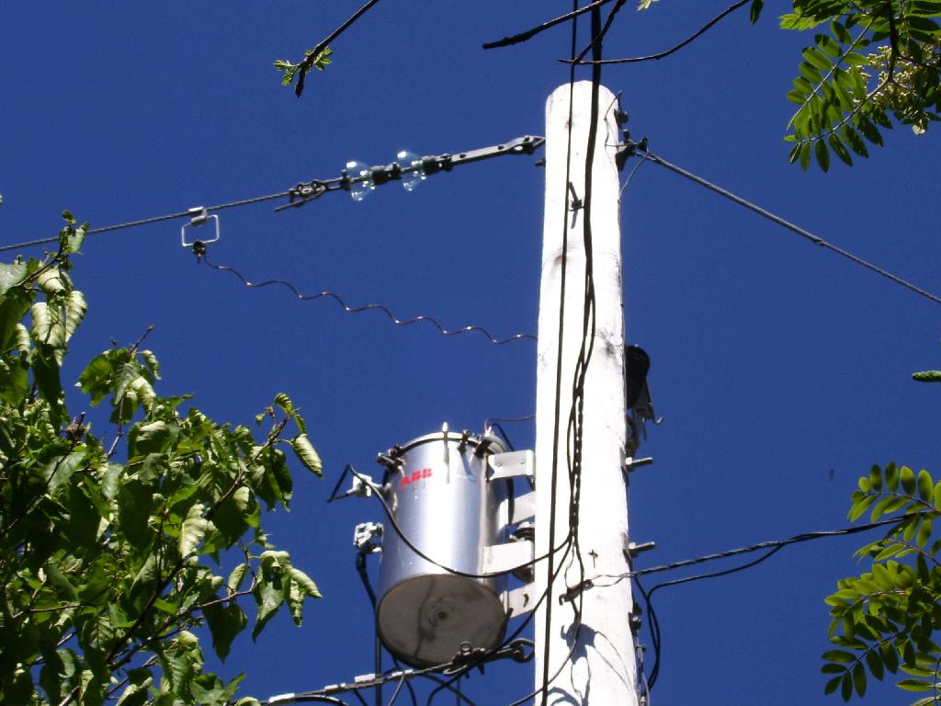

Figure 6: New 7.2kV:234V 10kVA pole transformer.

Reception Experiments:

Signals can be received at levels below the audible threshold by using Fourier transforms of the received audio via a computer sound card. While this lowered the bandwidth, it also lowered the rate at which messages could be sent. In general, speeds of 0.04 WPM were used for transatlantic communications during favourable conditions, normal Morse could be copied by ear and the Newfoundland experiments are believed to be the first involving aural transatlantic reception of amateur 2200m signals.

As a result of reception experiments, knowledge was gained about low noise receiving antennas, preamps and reception techniques, including digital signal processing.

Regional reception experiments (up to 500 km) showed that LF was often more reliable than HF. Several instances of day time reception were noted during beacon reception experiments at sea at distances where HF or 160m ground wave would be too weak and at a range where the sky wave could not be received. Although some amateurs in Newfoundland were able to receive the long wave beacon transmissions on 137.777 kHz, few had the necessary specialised receiving equipment such as resonant loops or tuned receiving antennas. This area remains fertile ground for fostering technical investigations within the service. Night time reception of LF at more than 500 km was limited by higher levels of noise.

Conclusions:

There have been several developments as a result of this experiment. Much has been learnt about digital signal processing, direct digital synthesis, and specialised weak signal reception techniques including loop and active receiving antennas. Experimental modes using slow speed CW and FSK were developed and successfully used to establish 2-way LF communication. Class E LF transmitter designs with Hexfets were explored along with high stability carrier generation and calibration against atomic standards. Much was learnt about preamps, transmitting aerials, methods of tuning transmitting aerials and the effects of environmental variability on antenna properties. Methods of effective maintenance of antennas in harsh environments have been developed. We have also learnt much of propagation at local and transatlantic scales.

In addition, there has been much international camaraderie and recognition of Canadian amateurs in the forefront of experimentation and innovation. There is much room for additional work such as accurate LF field strength measurements and more quantitative results for power line coupling.

These experiments have shown that is not difficult for amateurs to make meaningful use of 2200m in typical back yard scenarios, with aid of sophisticated computer programs and assistance from established experimenters. Practical LF communications systems have been developed and used by amateurs in Canada. Additionally, much has been learnt about the associated LF instrumentation and antenna design. Further, means of reducing power line coupling of LF RF have been found. It has been determined that an effective low impedance earth connection can be established that is independent of the AC mains. There were also some interesting developments since the last authorization renewal. These have served to increase awareness and interest in amateur LF experimentation and innovation.

The LF experiment in Newfoundland has showed that a practical LF transmitting station is well within the reach of any technically competent amateur. Although the original proposal sought to investigate propagation and antenna design, many other aspects of the radio art and science were explored. This included weak signal methods, the use of digital signal processing, direct digital synthesis, internet protocols for near real time signal strength measurements at remote sites and the use of computers to automate communications systems. There were no reports of interference of any kind to other services.

Acknowledgements:

The author acknowledges the assistance and encouragement of VE3IQ and VE3PU and the late VA3LK, and VE3OT, VE7SL, and many members of the Marconi Radio Club of Newfoundland and to other VO amateurs who provided signal reports and expressed interest. W1TAG, G3NYK, M0BMU and G3LDO were very helpful. The RSGB, ARRL of course RAC are due a great deal of gratitude, along with all other contributors mentioned in the references and any others who were inadvertently not mentioned. Please see the VO1MRC web page for a more comprehensive list of collaborators for this experiment. The forgoing report is a work in progress and does not purport to be a comprehensive review of the experiment.

Appendix 1: Experimental Proposals

Title: Antenna design and propagation characteristics on the 2200 metre band.

Author: J. Craig VO1NA, Experiment Coordinator
Torbay NL

Date: 30 January 2003

Purpose:
To conduct experiments with transmission and reception in the frequency range of
135.7 to 137.8 kHz with an aim to better understand understand: i) design and optimisation of LF transmitting and receiving aerials and associated measuring apparatus ii) the characteristics of propagation in the LF portion of the spectrum

Introduction:
Since the Washington Convention in 1927, radio amateurs have been required to constrain their transmissions to 200 metres and down. As a result, there has beenvery little experimentation in the wavelengths longer than 200 metres by amateur radio operators. Over a decade ago, some amateurs in Canada were granted special authorisation to transmit in the 160-190 kHz band and more recently in the 2200 metre band (135.7 to 137.8 kHz). These experiments culminated in the spanning of the Atlantic ocean by Mr L. Kayser in 2001, however there remains much to
be discovered about transmission, propagation and apparatus design on this band.

This experiment will augment the findings of the previous investigators and provide an opportunity to promote to the technical aspects of amateur radio and interest in low frequency experimentation.

Method:
A transmitter will be used to work CW (A1A) and FSK (F1B) between the frequencies of 135.7 and 137.8 kHz. Emissions outside this range will be suppressed by at least 30 dB. The bandwidth of the emissions will be 100 Hz or less. A 25 metre high tower or 100 metre wire will be used as a transmitting aerial. A variety of tuning and grounding systems will be tried to optimise the efficiency of the aerial. The radiated power will be limited to 1.0 Watt ERP.

The transmitter will operate on the basis of non-interference to authorised users by transmitting the call sign VO1NA in Morse code at regular intervals of about 4 times a minute. This call sign has been assigned to the author. Morse code at much slower speeds will also be sent. Signal reports will be solicited from other radio amateurs. Communications will be attempted with other authorised stations including radio amateurs in Canada, Europe and the United States. The experiment will be conducted over a period of one year, from 20 February 2003 to 20 February 2004 subject to approval from Industry Canada and the endorsement of Radio Amateurs of Canada.

The transmit frequencies will be monitored when the transmitter is off the air. If we receive a request to stop sending, we will comply or change frequency, as required. It is understood that any authorisation will be on a secondary basis.

Publicity:
The operation will be publicised world-wide by Radio Amateurs of Canada bulletins and by the Marconi radio Club of Newfoundland. Periodic updates will be posted to the MRCN (VO1MRC) web page.

Results:
Details of the experimental transmitter, antenna and tuner along with reception reports will be will be submitted to the Editor of TCA, the RAC Journal, for publication. Copyright for the experimental results will be retained by the authors.

---------------------
Title: Short range LF communication experiments.

Author: J. Craig VO1NA 18 Feb 2004

Industry Canada File Number: 200200232

Purpose:
To develop and evaluate an amateur radio LF communication system at ranges of up to 300 km in Newfoundland.

Amateur experimentation on LF has been conducted in many countries around the world. A world wide LF allocation has been placed on the agenda for the next WRC in 2007 by Canadian representatives.

Very little 2 way communications have been conducted on 2200 metres within Canada by amateurs, although intercontinental contacts have been made using advanced digital signal processing and slow speed Morse code. It is intended to set up a second LF station which will use the call sign VO1MRC, the Marconi Radio Club station, of which the author is the sponsor and to operate this station at different locations within Newfoundland. It is proposed to establish communication on LF at short ranges (up to 20 km) this winter and spring. During the summer, greater distances will be attempted. It is expected that LF will provide more reliable communications that existing MF/HF amateur allocations at distances greater than about 100 km because of the greater range of the LF ground wave.

The use of the VO1MRC call sign for this project has been approved by the Marconi Radio Club. The transmitter will constructed and installed under the direction of the author. Communication will be attempted with the fixed LF station VO1NA from different sites. The parameters of the operation will be as per the original authorisation for VO1NA dated 20 Feb 2004. No transmission will take place without prior approval from the ARSC and the regional IC office for an transmission from that site. This is to preclude interference to DND sites in Newfoundland.

Reports outlining the progress of the experiment will be forwarded to RAC and published in TCA. It is hoped that this will focus attention on low frequency experimentation at the regional and national level.

Appendix 2 Bibliography of LF Canadian
Experimentation

(This is not a complete listing.)

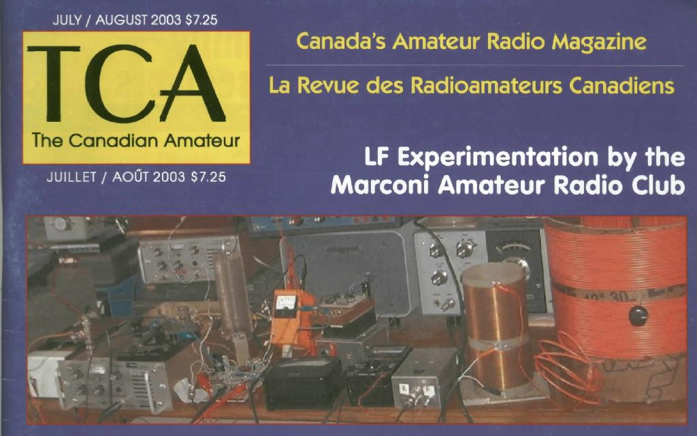

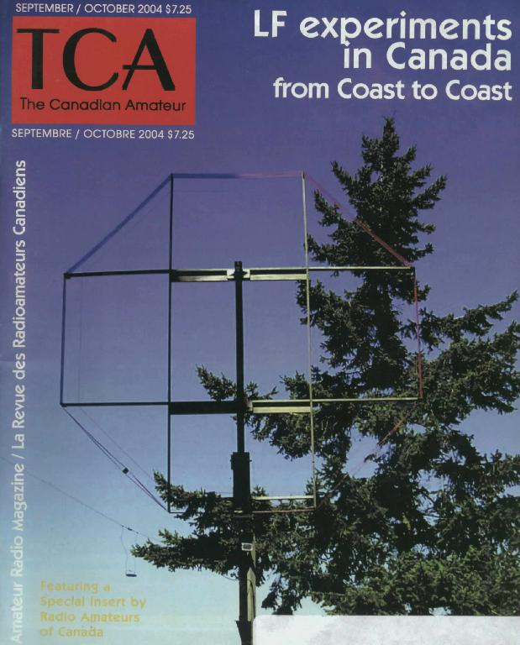

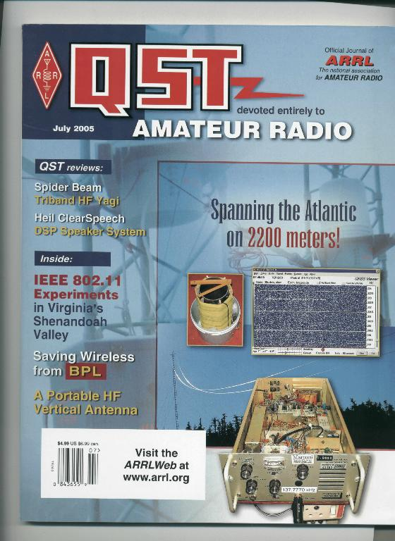

Reprinted with permission from July 2005 QST; copyright ARRL.

"Long Wave Experimenting in Newfoundland" Joe Craig VO1NA.
Local St John's newsletter. April 1995.

Papers were published by L. Kayser VA3LK on the first Canadian LF QSO in July 2000 with VE3OT and the first LF transatlantic QSO of Feb. 2001 and also the work of VE1ZJ/VE1ZZ.

5 March 2003: Letter of Authorisation for VO1NA on 2200m.

"A progress report of experiments on 2200m by the Marconi radio club of Newfoundland" J. Craig TCA 31:4 Jul/Aug 2003 p 42

"Update on experiments on 2200 metres" J. Craig TCA 31:6 p.52 Nov/Dec 2003

"First Western Canadian Contact on 2200metres" S. McDonald and S. Tilley p38 TCA Sept/Oct 2004

"Progress Report on LF Experimentation in NL" J. Craig, R. Dodge and R. Peet. Sept/Oct 2004 TCA p. 39

"Experimental LF QSO in Eastern Canada uses conventional CW" J. Craig
TCA Nov/Dec 2004 p. 48

"Transatlantic Reception of QRP 1600 Metre Signal" J.Craig and A. Melia and H. Wolff. p 13 TCA May/June 2005.

"The Transatlantic on 2200 Meters" J. Craig and A. Melia. QST 89, no. 7 Jul 2005.

"Getting started on 2200m" By S. McDonald. Jul/Aug 2005 TCA

"A West Coast LF Adventure" S. McDonald. Jan/Feb 2006. TCA p44-47

"Modernising the XH100 Receiver" J Craig TCA Mar/Apr 2007

"RAC/MRCN LF Experiment Results in Another Transatlantic LF QSO" J. Craig TCA May/June 2007 p 34(?)

TCA Covers: VO1NA (Jul/Aug 2003) and VE7SL (Jan/Feb 06)

Summaries in "Around the Corner" (p 10 TCA unless otherwise indicated):
-----------------------------------------------------------------------
Long Wave low frequency work. Jul/Aug 2003
2-way transatlantic QSO from NL Sept/Oct 2003
More news on propagation on 2km band p 9 May/June 2004
Conventional CW LF QSO p 7 Nov/Dec 2004
LF experimentation by radio amateurs Jan/Feb 2006
Another Transatlantic 2200m QSO Mar/Apr 2006
Canada US LF cross-band QSO (VE7SL) QSO Mar/Apr 2006
LF experimentation by radio amateurs Jan/Feb 2006

Reports in Club Newsletters
----------------------------
Halifax ARC Reflector 68,8 October 2007
Poldhu ARC Newsletter June 2005
MRCN Newsletter.
Long Wave Club of America "Lowfer"

News Articles in National Journals.

QST p 84 Feb 2005 with photo of antenna/25m tower, VO1NA on 137.777 kHz.
Rad Com LF Column June 2004 VO - UK QSOs, regular reception in Europe of VO1NA 100W TX, RN6BN copied VO1NA at 6600km.
Rad Com Apr 2006: Reception of 5 WPM CW from VO1NA in Eu. More transatlantic contacts on 2200m
Rad Com LF Column Feb 2008 p 30. Transatlatic 1600m.

RAC bulletins announcing various LF experiments
------------------------------------------------
27 May 2003
The Marconi Radio Club of Newfoundland is promoting interest in long wave low frequency work on 136 kHz

2007: Canada Ending 136 kHz and 5 MHz Special Authorizations

ARRL Online Bulletins and newsletters

www.arrl.org/arrlletter/03/0530/ Newfoundland club promoting interest in LF work:
www.arrl.org/news/stories/2003/05/29/101/ (as above)

www.arrl.org/arrlletter/04/1112/

www.arrl.org/index.php3/ofst/3090 W1TAG, VO1NA and WD2XDW

www.arrl.org/news/stories/2004/11/12/2/
Three North American LF signals received in UK

www.arrl.org/news/stories/2004/11/18/1/
Experimental Licensees Moving Low-Frequency Agenda

www.arrl.org/?artid=6125 Atlantic spanned again on 2200 meters; tuning shed

www.arrl.org/news/stories/2003/05/29/101/ NL Club promoting LF

http://www.arrl.org/w1aw/2007-arlx002.html ARLX002 Canada Ending 136 kHz and 5 MHz Special Authorizations

UK LF Site: www.wireless.org.uk
VE7SL: http://www.imagenisp.ca/jsm
RSGB LF Group Reflector
LWCA Group Reflector

----------------------------

"VE7SL - 2200m EXPERIMENTAL OPERATIONS REPORT"

Station Location: MAYNE ISLAND, B.C.

Station Operator: Steve McDonald

OBJECTIVE

There were two subjects of this experimental licence:

1) To observe the propagation characteristics of amateur 2200m signals into and over mountainous terrain.

2) To test typical small-lot LF antenna systems capable of communicating on 2200m.

METHOD

In order to gather information for either of the two objectives, it was first necessary to build a complete station that was capable of transmitting on 2200m at 'typical' amateur power levels, as well as receiving signals in this somewhat challenging part of the radio spectrum. Once a capable transmit / receive platform was developed, it was intended that as much two-way communications as might be possible under the limited terms of the licence would be undertaken as well as numerous one-way (beaconing) tests should be implemented.

The first year of the licence period was taken up with the construction of suitable equipment that could be used for the tests (APPENDIX A). After building a number of European-designed transmitters, I settled upon one utilizing a single IRF-540 switching-FET. This transmitter proved to be inexpensive, simple in design, able to produce a useful level of output power (~100W) and was robust enough to handle the 100% duty-cycle requirements of the slow speed (QRSS) CW mode. During the final two years of the licence period, another transmitter was constructed and put into operation. This transmitter was capable of developing approximately 500W of output power.

Before and during the licence period, numerous receiving antenna systems were employed, consisting mainly of loops, both passive and tuned. As well as using a short active whip antenna, the main transmitting antenna was also employed for receiving.

Two different transmitting antennas were utilized during the licence period.

RESULTS

For much of the licence period, there were no other nearby stations with which to conduct two-way tests. The nearest other experimental licensee was Mitch Powell (VE3OT), in Ontario. Eventually another experimental licence was granted to a local amateur, Scott Tilley (VE7TIL), in Vancouver.

Scott was able to make two separate radio / camping trips into mountainous areas to the east of Vancouver which enabled some short-period observations to be made. On both occasions, a low-noise and effective LF receiving system was deployed as was an HF talk-back link so that real time observations and co-ordination could take place. On both occasions, the field station was surrounded by mountains and was located well within deeply forested areas. Both locations were approximately 150 miles to the east of the transmitter site. On both field tests, my 2200m 100W beacon was run continuously at a normal CW speed of 10WPM so that Scott could do as many listening checks as possible. Observations made during both tests indicated that no ground wave signal was received during the daylight hours, even when power was increased to approximately 500mw ERP. The beacon signal was only received during the twilight hours and throughout the night, leading us to conclude that the signal was arriving via sky wave propagation, even over this relatively short distance. Had the remote station been capable of transmitting on 2200m, two-way communications could have been easily established during the hours of darkness only. The overnight signal was also subject to moderate fading, either from changes in the reflective medium or from sky wave / ground wave cancellation. Further testing could be done with emphasis on simultaneous fade-rate observation compared to other frequencies from the same transmitter site.
Early in the propagation testing, it became apparent that although propagation into mountainous terrain would be challenging, propagation over the mountains would be relatively easy.

On the evening of August 5th, 2004, overnight beaconing tests were begun for several nights, with Mitch Powell, who had set up a portable LF receiving station at Didsbury, Alberta, approximately 500 miles to the east of the transmitter site and on the other side of the Rocky Mountains. The beacon was run at 90W output into a relatively small transmitting antenna (described below) in the QRSS slow-speed CW mode. Mitch was able to copy the signal easily throughout the hours of darkness for the entire length of the test. During this time, numerous "beacon heard" reports were received from several western states, including Washington, Oregon and California (APPENDIX B). Surprisingly, the Oregon report sited strong signals, both visually (ARGO) and aurally during the hours of daylight. It appeared that, even with a relatively small transmitting antenna, the 2200m signal was propagating easily via sky wave. Had there been transmitting stations at the various receive sites, two-way communications could have been readily established in the QRSS mode and in the Oregon location, via normal speed CW.

The secondary objective of the experimental licence application, observing the effectiveness of simple 'backyard' LF antenna systems, began with the above tests in August, 2004. It should be noted that any amateur antenna systems (especially those confined to typical domestic lots) will be extremely inefficient on 2200m. A normal 'minimal standard' quarter-wave vertical radiator would need to be over 1600' high on 2200m to achieve a nominal radiation efficiency of 50%. As well, at these frequencies, horizontal radiators are almost completely ineffective as they suffer from very large ground absorption losses as a result of ground-proximity coupling. Anything less than a 1600' vertical on 2200m results in an immediate and severe degradation of radiation efficiency!

The first antenna tested was a short 30' vertical wire, employing a three-wire top hat to increase radiation efficiency. The top-hat, which was centered on the vertical radiator, was approximately 50' in length. In order to achieve resonance on 2200m, a large loading-coil of approximately 3mH was required. In addition, the antenna was fed against a small ground system consisting of approximately forty buried radials, each about 40' in length. With the 90W transmitter used in combination with this antenna system, the ERP was estimated to be less than 100mw.

It should be noted that calculated ERP and actual measured ERP are usually quite different, with actual ERP usually being less than theoretical values. As well, measuring actual ERP requires specialized instrumentation not readily available to amateurs. It would seem that, for this reason alone, limitations on power levels for amateurs operating on 2200m would be better if specified as DC POWER INPUT (W) or RF POWER OUTPUT (W) as is done on all other amateur bands. Measurement and enforcement of ERP levels is a much more challenging and time-consuming task compared to measuring DC power levels.

The second antenna tested was a larger version of antenna #1. This antenna consisted of a 60' vertical wire connected to the center of a three-wire top hat, approximately 100' in length. This antenna was run parallel to and suspended over the beach very close to the ocean. The antenna used the same buried radial system and required about 2mH of inductance to resonate on 2200m. This antenna was run exclusively with a new home built transmitter utilizing a pair of switching FET's and capable of developing approximately 500W of output power resulting in an estimated ERP of around 500mw.

After installing the new system, it quickly became evident how easily 2200m signals would propagate via sky wave on a regular basis. On most nights of normal (undisturbed) propagation, the beacon test signal was easily seen in the central U.S. On nights of above normal propagation (enhanced), 'heard' reports were regularly received from the eastern U.S., eastern Canada and from the southern U.S. Several 'cross band' contacts were completed with other amateurs in the U.S. and Canada, while transmitting on 2200m and listening on a designated HF talk-back frequency (APPENDIX B). As well, several normal-speed two-way CW contacts were completed on 2200m with experimental station VY1JA in Whitehorse, Yukon. This 1000 mile path, mostly North-South appears to be very reliable and at times, was viable throughout the daylight hours in the QRSS mode.

A number of different receiving antenna systems were employed throughout the test period. These consisted of a large 10' resonant air-core passive loop, a shielded single-turn amplified broadband loop, a 30" active whip antenna and transmitting antenna #2. All of the antennas performed well. The best performer was transmitting antenna #2, followed closely by the 10' tuned loop. In noisy city locations, I suspect that the loop antennas would provide a superior signal-to-noise ratio compared with the transmitting vertical because of their null-steering capabilities. The small 30" active whip proved to be an amazingly good performer for such a small footprint and when positioned in a quiet area of the backyard would be an effective receiving antenna for routine work on 2200m.

CONCLUSIONS

During the licence period, many hundreds of hours were spent transmitting in the beaconing mode (at high power) and at no time was there any interference to primary users evident or brought to my attention. It would appear, from personal experience, that amateur LF operations can co-exist with the primary users of the 2200m band without conflict. It should also be noted that the reciprocal would also appear to be true in that no interference from primary users was noted during any of the experimental operations.

From the limited testing conducted specifically on propagating signals into mountainous terrain via ground wave propagation, it would appear that this is a difficult task when using power levels and antenna systems that might typically be found in amateur installations. Propagation via sky wave during the hours of darkness, into and over mountainous terrain, appears to be relatively easy.

Again, from the limited amount of time conducting antenna tests, it would appear that even though a typical backyard LF antenna system would, by necessity, have an extremely poor radiation efficiency, worthwhile results can be realized from such a system.

With very few stations in Canada holding valid experimental licences, it was difficult to gather large amounts of hard data during the licence period. All conclusions are based upon general observations taken during periods of varying propagation conditions.

During the term of the licence one important objective was to keep as many amateurs in Canada and throughout the world, informed and updated on Canadian LF activity. To facilitate this, a web site was developed to disseminate information on all aspects of 2200m activity, including information on equipment construction, operating QRSS and on the Canadian experimental licensing program. As well, numerous articles were written and published (APPENDIX C) in the RAC journal (TCA), describing various LF activities. Numerous 'news releases' were also written and published in both the ARRL LETTER and TCA, describing many of the LF operating activities undertaken during the experimental program. As a result, hundreds of inquiries were fielded over the past few years regarding Canadian LF activity, hopefully inspiring others to become active on our 'new' LF band. An amateur allocation on 2200m will be the ideal 'experimenters' band, requiring amateurs to seek out and acquire new skills related to equipment, procedures and propagation, in order to push the boundaries afforded by this new opportunity - a positive step for amateur radio in Canada.

APPENDIX A

TRANSMITTER #1 - 100W OUTPUT

This is the transmitter built for tests with Oregon and Alberta. This particular transmitter was later shipped up to VY1JA in the Yukon where, thanks to Jay's excellent antenna system, it was heard in Europe as well as in New Zealand during one of the Trans-Pacific Tests! Running 24 volts on the final will produce 100 watts into a 50 ohm load.

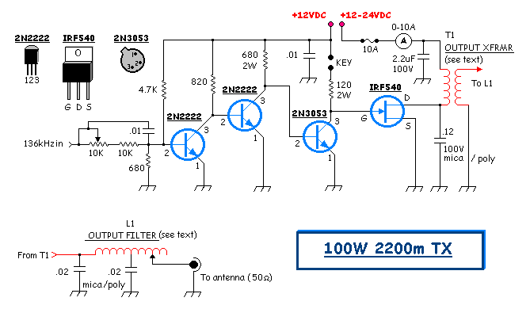

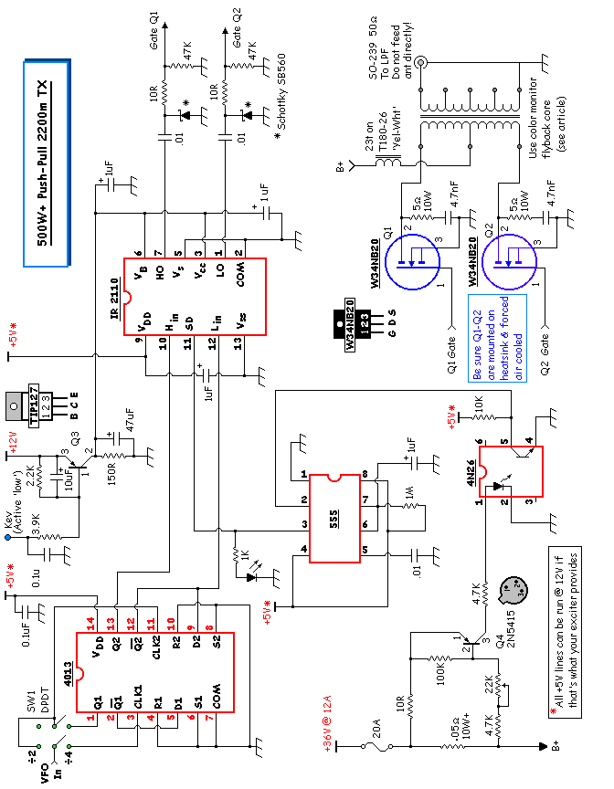

L.F. STATION
Shown below is my 2200m experimental station, located on Mayne Island, B.C.
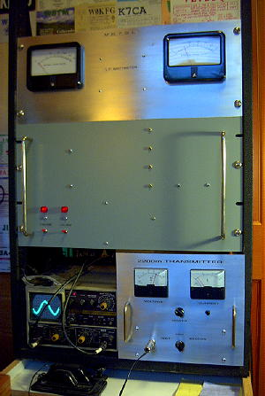

The transmitter, in the lower right corner, is my homebuilt version of the "LF Half-Kilowatt" designed by Scott, VE7TIL. My original signal source utilized a 4040 (binary counter) IC as a 2200kHz crystal oscillator driving a 4060 IC in a divide-by-8 configuration to produce a low-level signal at 275kHz. This has since been replaced by a homebrew DDS signal source. The 275kHz signal feeds a 4013 to provide a push-pull divide-by-2 output. The push-pull output on 137.5kHz is fed to an IR2110 push-pull FET driver which in turn drives a pair of inexpensive W34NB20 MOSFETs.
The panel above the transmitter contains two rack-mounted low-voltage power supplies strapped in parallel to run the transmitter, along with a small 12V / 5V supply for the IC's and fans.

The top panel houses my homebuilt 500W reflected power meter. It is an LF version of the Drake power meter. The lower left corner houses the scope which constantly monitors the transmitting antenna tuning.
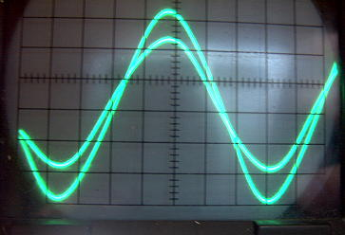
Both antenna CURRENT and antenna VOLTAGE are monitored. This allows easy tuning for resonance as well as making any matching adjustments with the loading coil very easy. The impedance of the antenna can be observed as well as its inductive or capacitive characteristics. It is fascinating to watch changes in the scope pattern while the antenna blows in the wind!
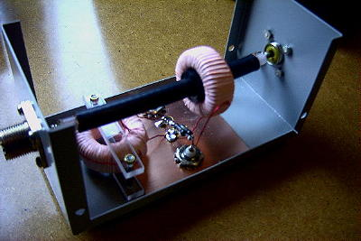

The Scope Match was homebuilt from plans by MØMBU and is shown in the 'LF Experimenter's Handbook' (G3LDO).

The transmitter is connected and matched to the antenna system by a large antenna loading coil. The loading coil was salvaged from a local ndb transmitter and is extremely rugged.

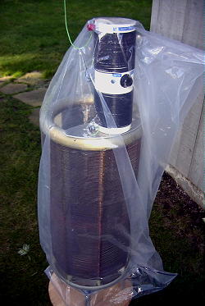

It is air-wound, on ceramic spacers, with #12 copper wire for a total inductance of 2.8mH. My antenna requires only 2.0mH to resonate at 137kHz so the antenna is tapped down on the coil. A homebuilt variometer, between the loading coil and antenna, is used for fine-tuning the system to resonance.

The variometer is a 'variable inductor', with an inner rotating coil connected in series with the outside coil. Rotating the inside coil changes the overall inductance plus/minus 300uH approximately.

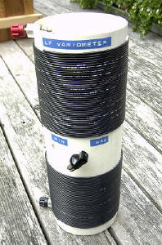

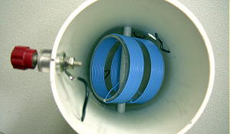

The transmitting antenna system (ANTENNA #2) is a 'Marconi T' 3-wire flatop. One end is attached near the top of a 100' Balsam tree while the other end attaches to my neighbor's Fir tree. Spacing on the top wires is 1m, with an overall length of approximately 30m. The antenna runs parallel to the ocean beach on the eastern shore of Mayne Island, providing an over-water horizon from Alaska to the north around to California to the south. At low tide, the effective height of the antenna is ~ 100' or more.

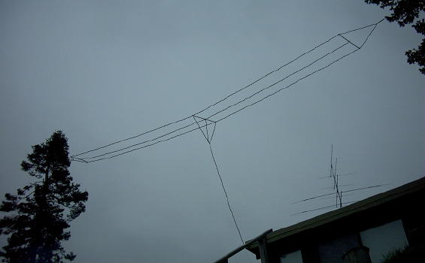

APPENDIX B

"Long Wave Experimenting in Newfoundland" Joe VO1NA. Local newsletter. April 1995.

Papers were published by L. Kayser VA3LK on the first Canadian LF QSO and the first LF transatlantic QSO of Feb. 2001.

"A progress report of experiments on 2200m by the MRCN " J. Craig TCA Jul/Aug 2003 p 42

"Update on experiments on 2200 metres" J. Craig TCA Nov 2003

"First Western Canadian Contact on 2200metres" S. McDonald and S. Tilley p38 Sept/Oct 2004 TCA

"Progress Report on LF Experimentation in NL" J. Craig, R. Dodge and R. Peet TCA Sept/Oct 2004 tca. p 39.

"The Transatlantic on 2200meters" J. Craig and A. Melia. QST 89, no. 7 Jul 2005.

"Getting started on 2200m" By S. Mcdonald. Jul/Aug 2005 TCA

"A West Coast LF Adventure" S. McDonald. Jan/Feb 2006. TCA p44-47

"RAC/MRCN LF Experiment Results in Another Transatlantic LF QSO" J. Craig TCA May/June 2007

Assorted summaries in TCA and elsewhere:
-Around the corner p 10 Long Wave low frequency work. tca jul/aur 2003
-Around the corner p 10 Another ta 2200m qso tca mar/apr 2006.
-Around the corner p 10 canada us lf crossband qso ve7sl qso tca mar/apr 2006.
-Around the world p 10 lf experimentation by radio amateurs. tca jan/feb 2006.
-Several News items reporting on LF in VO land in QST, Rad Com.
example: -news on p 84 feb 2005 qst. with photo of antenna/25m tower at vo1na on 137.777 khz.

-Several RAC bulletins announcing various LF experiments.

Transatlantic Reception of QRP 1600 Metre Signal J.Craig and A Melia and
H. Wolff. p 13 TCA May June 2005.

Experimental LF QSO in Eastern Canada uses conventional CW" J. Craig
TCA Nov/Dec 2004 p. 48

JULY, 2004 - Initial testing of the LF station (~ 90W) was followed by a two-way QSO on 2200m with Scott, VE7TIL, in Vancouver. Although the distance was not great, it was the first two-way 2200m work from Western Canada, the nearest other Canadian activity being in Ontario. This contact took place on July 11, 2004.
The first few nights of beaconing turned up several encouraging screen captures. The first was received from Steve, AA7U, in Elgin, Oregon. Steve's report indicated that the system was indeed working, actually far better than I had anticipated. Mitch Powell, VE3OT, vacationing in Alberta, also sent some similar captures, indicating that the 90 watt signal was making it over the Rocky mountains! Steve's Oregon capture is shown below:
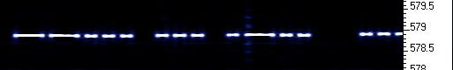
OCTOBER, 2004 - My first crossband QSO was with John, VE7BDQ, located in Tsawwassen, B.C. John was using a homebuilt converter for receiving on LF, while transmitting on 80m CW. John's receive antenna was a large coil and tuning capacitor located outside in the backyard! He now has a new 8' loop antenna for LF work.
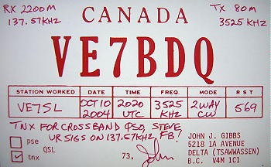

DECEMBER, 2004 - In late November, extensive antenna renovations were completed to the 3-wire flatop when the antenna was lengthened and raised much higher. As well, the new 500W transmitter was completed and ready to go. The first overnight test on December 4th and 5th resulted in several encouraging signal reports as well as a new crossband QSO with Roger, KØMVJ, near Duluth, MN (EN36vt).
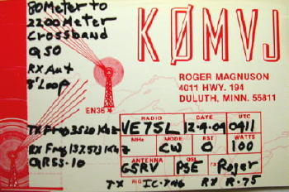
Roger initially reported that my QRSS30 signals were very strong and that I should go to QRSS10. He then reported that the QRSS10 signal was 'easy copy' and that I should speed up to QRSS3. It turned out that QRSS3 was a little too weak so I went back to QRSS10. The capture below shows the difference between the two speeds.
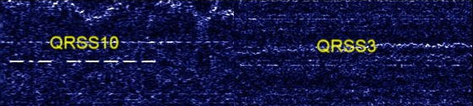
Bryce, KIØLE, also in Minnesota was watching that night and sent along a screen capture of my signal report to Roger. The capture below shows my "5NN 5 73 TU" transmission. I stopped sending the second "599" when Roger called on 80m CW with a string of 'R's indicating he had received his signal report OK.

That same night and the following night, screen captures were received from Jay, W1VD, in Burlington, Connecticut (FN31ms). Jay reported seeing the signal all night and even past his sunrise. Here is his midnight screen capture of my QRSS30 signal at ~ 2500 miles distance.
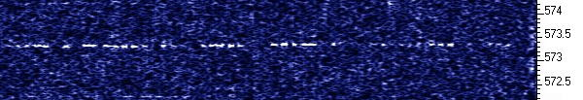
Again on both nights, Mitch, VE3OT near London Ontario (EN93ja), reported copy 'all night long', with signals peaking shortly before dawn. Mitch provided this predawn capture.
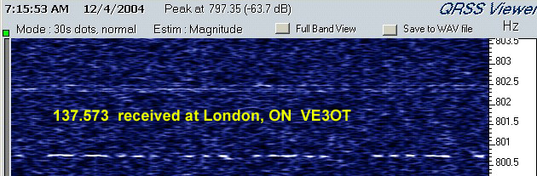
DECEMBER 19, 2004 - VY1JA in Whitehorse, YT, indicated that he was ready to look for LF signals with SPECTRAN, an FT-990 and his 40m wire antenna. After running the beacon for a short time, Jay was able to report good copy so a two-way crossband QSO was scheduled and completed later that evening. Jay was transmitting on 80m CW and listening on 137kHz to my QRSS3 signal.
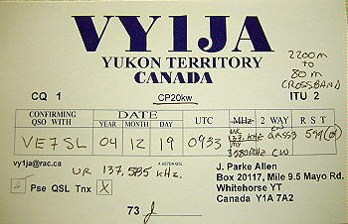

QRSS3 beacon signal as received in Whitehorse, Yukon, during our contact.

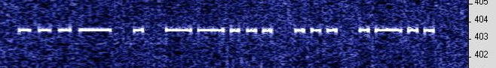
After our crossband QSO, I let the LF beacon run all night at 50 watts output. Jay reported that the 50W signal was also good copy in Whitehorse.
Jay is in CP20kw, approximately 1000 miles to the north.
DECEMBER 20, 2004 - A fine two-way crossband QSO was completed with Dan, W7OIL, in southern Washington (CN85pu). Dan indicated that the signal was strong on Argo and that he could hear the signal as well.
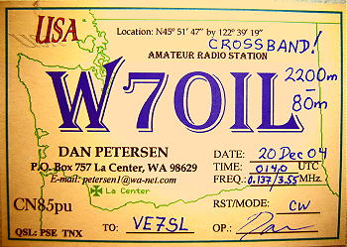
DECEMBER 27, 2004 - Another overnight beacon session resulted in several reports from Alaska (KL1X near Anchorage) to eastern USA.

Steve, W3EEE in Maryland (FM19qj), monitored all night and sent this pre-dawn capture from 2350 miles away.

Dexter, W4DEX in North Carolina (EM95tg) at 2360 miles, monitored with one leg of his 160m dipole!
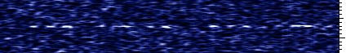

Not to be outdone by his neighbor (W3EEE) Lloyd, W3NF, also in Maryland (FM19mh), sent proof of his reception.

W1VD in CT again reported hearing the beacon, indicating best reception from 0515 EST until sunrise fadeout.

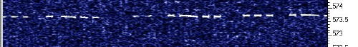

DECEMBER 28, 2004 - Lewis, WA4LIP in Lucedale, Mississippi (EM50vq) at 2175 miles, reported reception using his 40' x 40' NW-SE loop and IC-706/preamp.

JANUARY 15-16th, 2005 weekend was highlighted by three crossband QSO's with stations in the Vancouver-Victoria area. Borge, VE7VB in Victoria, a long-time LF experimenter, used his 50m longwire to receive on LF, along with a beautiful old McKay 3001A receiver. VE7WU, Allan in Victoria, called the next day after configuring his 40m Delta loop and Icom 775 for LF receive. Ralph, VE7XF in Tsawwassen, combined his 160m inverted L and FT-1000MP for LF receiving. It was great to see the effort put forth by these amateurs -- obviously there is much interest in 2200m developments here on the west coast!

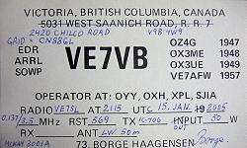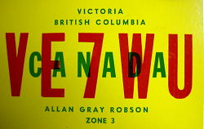

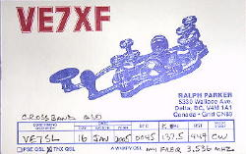

JANUARY 29, 2005 - A regular CW to CW crossband QSO was completed on Saturday night with VY1JA near Whitehorse, Yukon. Jay was on 80m CW while I transmitted on 137kHz CW at around 10 wpm. Jay reported exceptional signal levels on QRSS60 and suggested we attempt the two way CW crossband QSO which took about 9 minutes to complete. Once Jay became licenced for 2200m, several real-time normal speed CW contacts were completed with signal levels often reaching 599 in the predawn hours.

DECEMBER 31, 2005 - A nice crossband QSO was completed with Andy Flowers, KØSM in Lincoln, Nebraska (EN1Ørt). Andy was transmitting on 80m CW while using his low band dipole for receiving on 2200m.

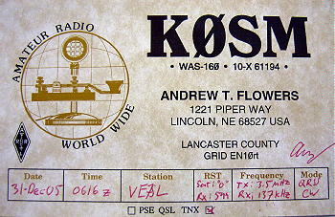

APPENDIX C

***************
The ARRL Letter
Vol. 23, No. 29
July 23, 2004
***************

* First western Canada LF QSO reported: British Columbia amateurs Steve
McDonald, VE7SL, Mayne Island, and Scott Tilley, VE7TIL, Vancouver
reportedly completed the first western Canadian contact on the 2200 meter
band on July 10. McDonald said the contact between the two stations on
137.754 kHz spanned a distance of approximately 50 km (about 31 miles).
"VE7TIL utilized slow-speed CW--QRSS3--mode, while VE7SL used normal CW,"
McDonald said. VE7TIL was running a homebrew transmitter that ran about 1
W output, while VE7SL was using a homebrew crystal-controlled exciter into
a single FET amplifier at 100W output. "Both of us used similar antenna
systems for transmitting--a loaded three-wire flattop T," McDonald said,
and small loop antennas for receiving. McDonald said he hoped their
efforts would stimulate more interest in LF in western Canada. For more
information about 136 kHz activity and equipment, visit The VE7SL Radio
Notebook: http://www.imagenisp.ca/jsm/

***************
The ARRL Letter
Vol. 25, No. 13
March 31, 2006
***************
* Low-frequency experimenters seek reports, crossband skeds: The next round
of LF transpacific testing between ZM2E, Quartz Hill, New Zealand, and
VA7LF, S Pender Island, British Columbia, will take place April 3, 4 and 5.
Testing will begin shortly after sunset at VA7LF (approximately 0630 UTC)
and will continue until sunrise (approximately 1400 UTC). The frequency will
be 137.7890 / 137.7886 kHz (0.4 Hz shift) using FSK90. Following a schedule
with VA7LF, ZM2E will continue with R6L until sunrise in New Zealand.
Reception reports via the reflectors are encouraged, and the VA7LF site will
be Internet equipped. "If we are able to get things set up smoothly, we may
be on the air for testing on Sunday night, April 2," said Steve McDonald,
VE7SL. "Since we will be at our maximum ERP limit, we hope to have some time
available to attempt some crossband HF-LF CW-CW QSOs or QRSS-CW contacts in
our early evening hours (0300-0600 UTC)." Interested stations should contact
McDonald via e-mail,

http://www.arrl.org/news/stories/2006/04/26/1/

Canadian Team Tries Again to Contact New Zealand on 2200 Meters

NEWINGTON, CT, April 26, 2006 -- Earlier this month, Scott Tilley, VE7TIL, and I led a team of Canadian hams in trying to make the first two-way contact between North America and New Zealand on 2200 meters. Using the call VA7LF (in honor of our mission using low frequency), we attempted the contact from South Pender Island, British Columbia, Canada between April 3 and 5.

Assisting in this project were Martin MacGregor, VE7MM, and John Gibbs, VE7BDQ.

Using an aluminum tower 40 feet high, we added two 20-foot aluminum sections to the top of the tower, as well as a large 150-foot two wire top hat spaced 10 feet across. Another 25 feet of wire was extended from the base of the antenna over the cliffside, ending just above the beach, where it was matched and fed with 50 ohm coax, for a total of 105 feet. The entire antenna system was brought into resonance on 137 kHz; the big vertical required 1.9 mH of inductance to bring it down to 2200 meters.

Murphy's Law of propagation was evident all three nights of the test, as the A and K indices were highly elevated. In addition, there were strong geomagnetic storms and aurora displays so intense they could be seen in the central USA.

Even with the poor propagation, VA7LF and ZM2E (Quartz Hill, New Zealand) managed to exchange signals on 2200 meters. Using slow speed DFCW90 and DFCW60 (this is frequency shift keyed Morse: a "dot" is sent by having the transmitter send on frequency_1 and a dash by having the transmitter send on frequency_2; the difference between frequency_1 and frequency_2 is typically 0.1 Hz to 0.5 Hz), signals from both ends were copied on all three nights.

The third morning had the best results: ZM2E's signal suddenly elevated 25 dB over the noise and acknowledged our call as a perfect copy of the beacon signal. This was an invitation to begin a formal contact sequence, but as the sun was starting to rise on South Pender Island, the darkness disappeared before full calls could be exchanged.

On the third night just prior to sunset, VA7LF took advantage of the strong groundwave signal and made a number of crossband contacts, using 160-2200 meters, to Washington, Oregon and British Columbia.

VA7LF has attempted to make this contact since 2004. Although not reaching the goal of a valid contact, we will try again. -- Steve McDonald, VE7SL

***************
The ARRL Letter
Vol. 25, No. 25
June 23, 2006
***************
* Yukon Territory radio amateur exploring LF spectrum: J Allen, VY1JA, of
Whitehorse, Yukon Territory, recently became the first radio amateur to put
the Yukon on LF. Allen has joined the half-dozen or so Canadian hams
authorized to experiment on low frequencies. Perhaps best known as the ham
who most often hands out the hard-to-work Northern Territories multiplier,
Allen now is beaconing nightly on 137.574 kHz. On May 25, Allen completed
the first LF QSO from the Yukon by working LF aficionado Steve McDonald,
VE7SL, in British Columbia. "Running just 30 W into a loaded inverted L, J's
ERP was likely well below 100 mW," McDonald estimated. He reports Allen's
very slow-speed CW signal was 100-percent copy using ARGO software on the
receiving end. In Whitehorse, Allen reported that VE7SL's signal was strong
enough to copy by ear at normal speeds. Observed McDonald: "At 1000 miles
distance, the initial QSO demonstrates that amateurs can enjoy
inter-provincial or out-of-state CW ragchews on 2200 meters using simple
stations and backyard antenna systems." There's more information on 2200
meter activity in "The VE7SL Radio Notebook" http://www.imagenisp.ca/jsm

***************
The ARRL Letter
Vol. 25, No. 37
September 15, 2006
***************
* Long-distance CW QSO marks milestone in LF experimentation: Steve
McDonald, VE7SL, and J Allen, VY1JA, are claiming the first long-distance,
low-frequency aural CW contact between two Canadian amateurs. The QSO in the
vicinity of 136 kHz (2200 meters) between VY1JA in Whitehorse, Yukon
Territory (CP20) and VE7SL on Mayne Island, British Columbia (CN88) took
place Friday, September 9, at 0705 UTC. The distance between the two
stations is approximately 1000 miles. "It was nice not having to rely on
computers or QRSS [very slow-speed CW] mode to be able to work each other,"
McDonald said. "Copy was 100 percent at both ends with little fading." VY1JA
was running 200 W to a 100-foot top-loaded tower, resonated at 137 KHz,
while VE7SL was running 450 W to a 65-foot wire vertical and three wire
top-hat. While Canada has not yet allocated an Amateur Radio LF band,
Industry Canada has authorized several Canadian hams to experiment in the
vicinity of 136 kHz. "LF experimental work by Canadian amateurs continues to
demonstrate the suitability of 2200 meters for reliable two-way
communications with simple homemade equipment and without causing
interference to primary users of the band," McDonald concluded. For more
information on 2200 meter activity in Canada, visit The VE7SL Radio Notebook
http://imagenisp.com/jsm/136.html.

Additional Information: Report by Scott Tilley VE7TIL submitted to RAC;
List of Canadian amateur radio LF milestones compiled by J. Craig.

